- The time (T ) between two successive floods follows following probability density function, find the mean, mode, median, and the coefficient of variation of T.
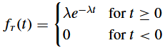
- Consider the following sample data for annual peak discharge (cumecs) at a gauging a station in Uganda. Determine all measures of central tendency, spread, flatness and asymmetry for the given sample data. Also, comment regarding the measures determined.
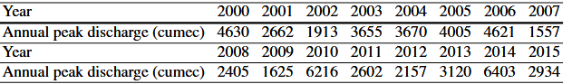
- Daily rainfall was recorded at a particular location for a period of 1 year. The data for rainy days are grouped into magnitude and number of days. The grouped data is presented in the following table. Plot a relative frequency histogram of the grouped data. Fit the exponential distribution to the histogram. Estimate the probability that a day selected in random will have rainfall greater than 45 mm.
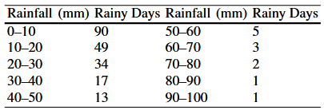
- In a certain stream, the annual maximum daily discharge follows Gumbel distribution with mean value of 12000 m3 /s and standard deviation of 4000 m 3 /s. What is the probability that the annual maximum daily discharge will exceed 16000 m3 /s? What is the magnitude of annual maximum daily discharge with a return period of 100 years?
- Peak discharge at a particular river gauging station is found to have a mean of 130 m3 /s and standard deviation of 30 m3 /s. Considering the peak discharge to follow lognormal distribution evaluated the following,
  - Probability of peak discharge being greater than 180 m3 /s
  - Probability of peak discharge lying in between 120 and 150 m3 /s.
- Consider the annual maximum flood discharge data at a river gauging station over a time period of 40 years as shown in Table 5.1. Construct the flood frequency plot, and estimate the following:
  - Flood magnitude with return period 10 years, 50 years, and 100 years;
  - Return period of a flood with 4000 cumecs magnitude
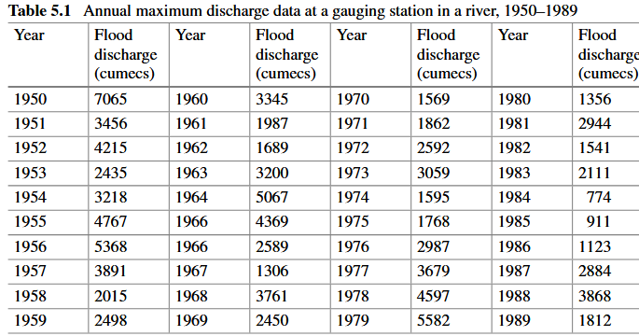
- Consider the data used in exercise above, and determine the 10-, 50-, and 100-year floods using normal and then log-Pearson type III distribution
- Consider a 50-year data of annual maximum 24 h rainfall depth at a particular place follows normal distribution with mean 92.5 mm and standard deviation 34 mm. Determine the magnitude of annual maximum rainfall with return period of 20 years.

